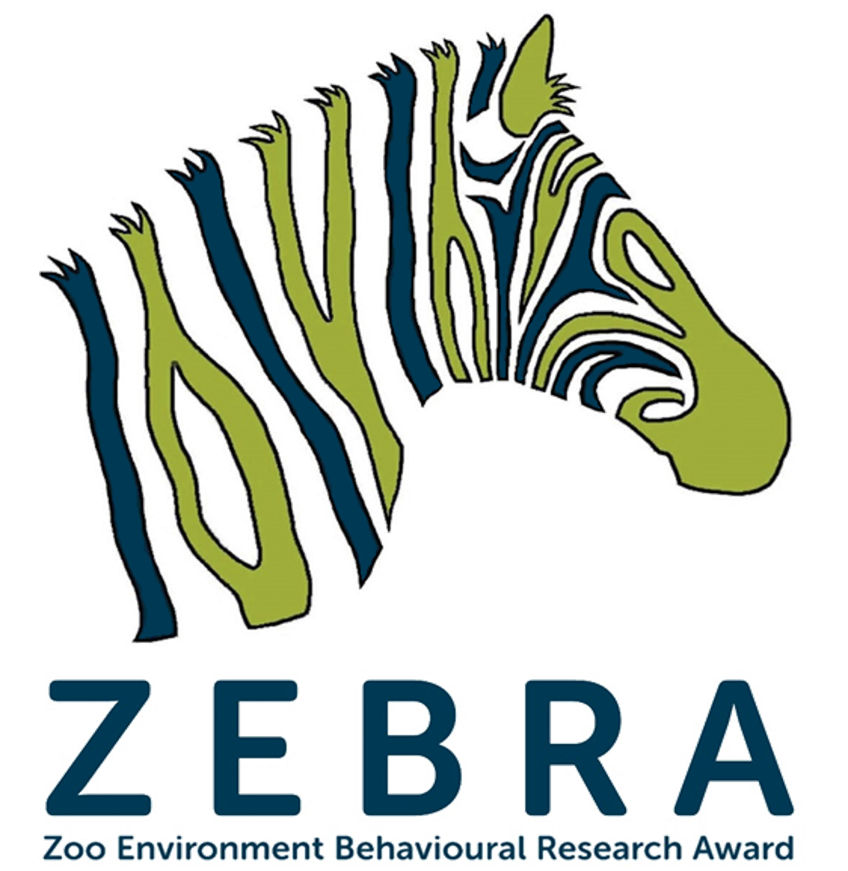
STUDENT BOOKING
FORM 2018/19

Name of Student: | Age (As of October 2018):
Gender: | Student Contact Tel:
Student Email: | School Name:
Students Home Address: | School Contact Tel:
Students Postcode: | School Address:
Student Details

Course Dates
RZSS ZEBRA will run every Friday at Edinburgh Zoo 2-4pm for 13 weeks from 26th October 2018 to 8th February 2019 (excluding December 21st, 28th and January 4th).
If you can commit to attending all of these dates, please check this box: □

Course Reference

RZSS ZEBRA may wish to contact a teacher who would support your application to this course at Edinburgh Zoo.

Please give details of a teacher who could provide a reference (if requested) below:

Teachers Name: | Teacher’s Email:
Department & Subject: | Do We Have Permission to Contact?:

How You Heard
How did you hear about this course? (e.g. Teacher/Leaflet/Website/Facebook/Twitter/Friend)

How To Submit (Note: Bookings are confirmed on a first come first served basis so submit as soon as possible)

Please return this form no later than Monday 10th September 2018 via email, titled “RZSS ZEBRA” to:

Email: education@rzss.org.uk Tel: 0131 314 0330

Next Steps
Bookings are confirmed on a first come first served basis. Once your booking form has been sent via email, you will receive confirmation via email within 3 working days confirming your booking (or else informing you that the course had already become fully booked). If you do not receive confirmation within 3 working days double check the email address and resend your form. To allow for as many schools to participate as possible, a cap of 5 students per school has been set, although this will be revisited if we do not get sufficient interest from multiple schools. If the maximum number of students from your school have been accepted onto the course, you will be informed and placed on our waiting list, in case of drop-outs or insufficient interest from other schools.
If your place on RZSS ZEBRA has been confirmed, full registration forms will be provided as well as more information about the RZSS ZEBRA programme, prior to the course start date. If for any reason you are no longer able to attend the course please let us know so that we may reallocate your place. Cancelling your place within 2 weeks of the course start date may result in you being charged a cancellation fee of £50.00.
In extreme weather Edinburgh Zoo may be forced to close. In these unlikely situations we reserve the right to cancel course dates at short notice. If this is the case we will make efforts to contact each student as soon as possible to advise (via contact details provided on registration forms). Alternatively, such updates will also be made available on via RZSS Education social media platforms (@RZSS_Education can be found on Twitter and Facebook). These platforms will also inform you of any other educational opportunities available at Edinburgh Zoo or The Highland Wildlife Park.

